**UNIT – V: Application Layer**

The application layer is the topmost layer in the OSI (Open Systems Interconnection) model and is also present in the TCP/IP model. It is responsible for providing network services directly to end-users and applications. The primary purpose of the application layer is to enable communication between different software applications and to support end-user services.

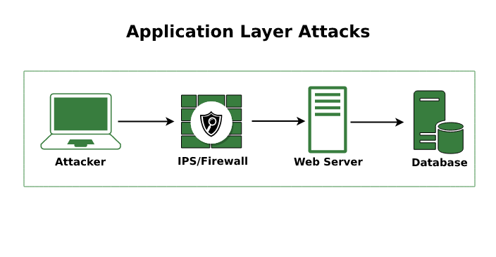

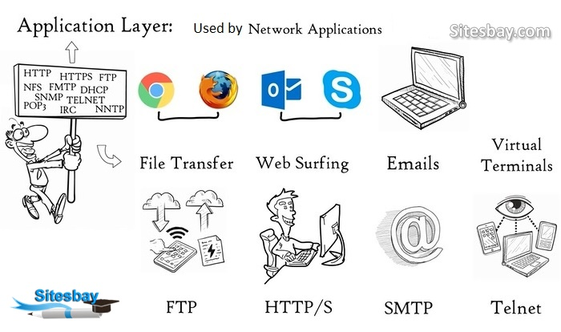

Key characteristics of the application layer include:

1. **High-Level Abstraction:** The application layer deals with high-level data representation, user interfaces, and application-specific communication protocols. It abstracts the complexities of lower layers for application developers and end-users.
2. **User Interface**: The application layer provides a user interface that allows users to interact with the network and access various network services. Examples include web browsers, email clients, and video conferencing applications.
3. **Application Protocols:** At the application layer, various application protocols facilitate specific functions, such as data exchange, email transmission, file transfer, and remote access. Some commonly used application layer protocols include HTTP, SMTP, FTP, DNS, SSH, and SNMP.
4. **Data Representation:** The application layer is responsible for data formatting, encoding, and conversion. It ensures that data is presented in a manner that the receiving application can interpret correctly.
5. **Interoperability:** The application layer ensures that applications running on different devices, platforms, and operating systems can communicate effectively with each other. Standardized protocols enable this interoperability.
6. **Port Numbers**: To establish communication, applications use port numbers, which act as endpoints for data exchange at the application layer. Each application or service is assigned a specific port number.
7. **Encryption and Security**: Application layer protocols often incorporate encryption and security mechanisms to protect data during transmission and to ensure secure communication.
8. Examples: Some examples of application layer services and protocols include:

* HTTP (Hypertext Transfer Protocol) for web browsing
* SMTP (Simple Mail Transfer Protocol) for sending and receiving emails
* FTP (File Transfer Protocol) for file sharing
* DNS (Domain Name System) for domain name resolution
* SSH (Secure Shell) for secure remote access

SNMP (Simple Network Management Protocol) for network management.

**Design Issues**

When it comes to designing applications or systems at the application layer, there are several important design issues that developers need to consider. These design issues help ensure that the application functions efficiently, securely, and meets the requirements of the intended users. Here are some key design issues for the application layer:

1. **User Interface (UI) Design**: The user interface is a critical aspect of application design. It should be intuitive, user-friendly, and visually appealing. Proper UI design enhances the user experience and makes the application easier to use.
2. **Functionality and Features:** Define the core functionality and features of the application. Prioritize essential functionalities and ensure they work reliably. Avoid feature bloat, which can make the application overly complex and difficult to maintain.
3. **Performance Optimization:** Applications should be designed to perform efficiently, respond quickly, and handle a large number of users if applicable. Performance optimization includes considerations for data structures, algorithms, and minimizing network overhead.
4. **Scalability**: The application should be scalable to accommodate increasing user demand and growing datasets. Consider distributed architecture, load balancing, and caching mechanisms to achieve scalability.
5. **Security:** Security is of utmost importance, especially when dealing with sensitive data. Implement secure communication protocols, encryption, proper authentication, and access controls to protect the application and its users from potential threats.
6. **Data Storage and Management**: Design an appropriate database schema and choose the right database management system to store and manage application data efficiently. Consider data integrity, backups, and disaster recovery.
7. **Error Handling and Logging**: Implement robust error handling mechanisms to provide meaningful error messages to users. Additionally, incorporate logging features to monitor application behavior and troubleshoot issues effectively.
8. **Interoperability:** If the application needs to interact with other systems or services, ensure that it adheres to relevant standards and protocols to achieve seamless interoperability.
9. **Usability Testing:** Regularly conduct usability testing with real users to gather feedback and make improvements based on user preferences and needs.
10. **Accessibility:** Design the application with accessibility in mind to ensure that people with disabilities can use the application effectively.
11. **Internationalization and Localization**: If the application targets a global audience, consider internationalization and localization to support multiple languages, date formats, and regional preferences.
12. **Maintenance and Upgrades:** Plan for regular maintenance and updates to keep the application secure and up-to-date with the latest technologies.
13. **Documentation:** Create comprehensive documentation for the application to help developers, administrators, and end-users understand its functionality, usage, and troubleshooting steps.
14. **Compliance and Legal Considerations**: Ensure that the application complies with relevant laws, regulations, and industry standards, especially if it handles sensitive data or financial transactions.

**DNS**

DNS stands for "Domain Name System," and it is a fundamental component of the internet infrastructure. DNS is a hierarchical and decentralized naming system used to translate human-readable domain names into IP addresses, which are used by computers to locate and communicate with each other over a network.

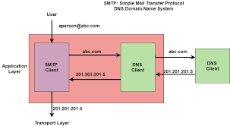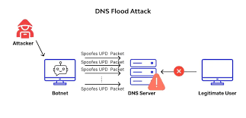

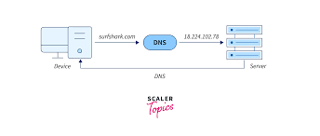

When you enter a domain name (e.g., www.example.com) into your web browser, the DNS system is responsible for converting that domain name into the corresponding IP address (e.g., 192.0.2.1). This IP address is used to establish a connection with the server hosting the website associated with the domain.

**Key features and components of the DNS system include:**

1. **Domain Names:** These are the human-readable names used to identify resources on the internet, such as websites, servers, and services. Each domain name consists of multiple labels separated by dots (e.g., [www.example.com).](http://www.example.com).)
2. **IP Addresses**: These are numerical addresses used to identify devices on a network. There are two types of IP addresses, IPv4 (e.g., 192.0.2.1) and IPv6, which are used to identify devices on the internet.
3. **DNS Resolver**: This is a software component used by client devices (e.g., your computer or smartphone) to look up domain names and resolve them into IP addresses. DNS resolvers are typically provided by internet service providers (ISPs) or network administrators.
4. **DNS Server**: DNS servers are responsible for storing and managing DNS records. There are different types of DNS servers, including authoritative DNS servers, which hold the official records for a domain, and recursive DNS servers, which perform lookups on behalf of clients.
5. **DNS Records:** These are database entries that contain information mapping domain names to IP addresses or other data. Common DNS record types include:

* **A record:** Maps a domain name to an IPv4 address.
* **AAAA record:** Maps a domain name to an IPv6 address.
* **CNAME record:** Creates an alias for another domain name (canonical name).
* **MX record:** Specifies mail servers responsible for handling email for the domain.
* **NS record:** Indicates the authoritative DNS servers for a domain.

1. **DNS Resolution Process:** When a client device needs to access a website or resource, it sends a DNS query to its configured DNS resolver. The resolver then starts the resolution process, which involves querying multiple DNS servers in a hierarchical manner until it finds the authoritative DNS server for the requested domain. The authoritative server responds with the appropriate IP address, and the resolver caches the result for future use.

**WWW**

The term "WWW" stands for "World Wide Web." It is not a separate technical component or system but rather a part of the broader internet. The World Wide Web is a collection of interconnected documents and resources that are accessible over the internet.



The World Wide Web was developed in the late 1980s and early 1990s by Sir Tim Berners-Lee, who is often referred to as the "inventor of the World Wide Web." His invention allowed for the creation of websites, web pages, and hyperlinks, which transformed the internet into a user-friendly, interconnected network of information.

Key features of the World Wide Web include:

1. **Web Pages:** These are individual documents or files written in HTML (Hypertext Markup Language) and accessible via unique addresses called URLs (Uniform Resource Locators). Each web page can contain text, images, multimedia, and links to other web pages.
2. **Hyperlinks:** Hyperlinks, or simply links, are elements within web pages that allow users to navigate between different web pages and websites by clicking on them. They enable seamless connections between various resources on the web.
3. **Web Browsers**: Web browsers are software applications that allow users to access and view web pages. Examples of popular web browsers include Google Chrome, Mozilla Firefox, Microsoft Edge, and Safari.
4. **HTTP and HTTPS:** HTTP (Hypertext Transfer Protocol) is the protocol used for communication between web browsers and web servers. When a website uses a secure connection, HTTPS (HTTP Secure) is used, which encrypts data exchanged between the user and the server.
5. **Web Servers:** Web servers are computers or software that store and deliver web pages and other resources to client devices (e.g., web browsers) upon request.
6. **Web Addresses (URLs):** URLs are addresses used to identify and access specific web pages or resources on the internet. For example, "https://www.example.com" is a URL that points to the homepage of the "example.com" website.
7. **Web Development:** The process of creating and maintaining websites and web applications is known as web development. Web developers use languages like HTML, CSS (Cascading Style Sheets), JavaScript, and various web frameworks to build interactive and dynamic web pages.

**HTTP/HTTPS**

HTTP (Hypertext Transfer Protocol) and HTTPS (HTTP Secure) are two protocols used for communication between web clients (such as web browsers) and web servers. They are the foundation of data transfer over the World Wide Web and play a crucial role in web browsing and accessing online resources securely.

**HTTP (Hypertext Transfer Protocol):**

HTTP is a protocol used for transmitting data over the internet. It is the standard protocol for communication between a client (typically a web browser) and a web server. When you enter a URL in your web browser and hit Enter, the browser sends an HTTP request to the server, and the server responds with the requested web page or resource.

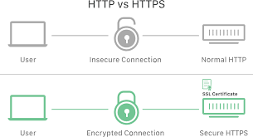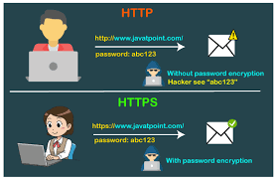

Key features of HTTP include:

1. **Stateless Protocol:** HTTP is stateless, meaning each request/response cycle is independent of previous ones. The server doesn't retain any information about previous requests from the same client. To maintain state across requests (e.g., login sessions), developers often use techniques like cookies or sessions.
2. **Clear Text:** HTTP data is transmitted in clear text, which means the information is not encrypted. As a result, sensitive data, such as passwords or credit card information, sent via HTTP can potentially be intercepted by malicious actors during transmission.
3. **Port:** HTTP typically uses port 80 for communication.

**HTTPS (HTTP Secure)**:

HTTPS is an extension of HTTP that adds an extra layer of security by using encryption to protect data during transmission. It is widely used for secure communication over the internet, especially for transmitting sensitive information like login credentials, personal data, and financial transactions.

Key features of HTTPS include:

1. **Encryption:** HTTPS encrypts the data transmitted between the client and the server using SSL (Secure Socket Layer) or TLS (Transport Layer Security) protocols. This encryption ensures that even if intercepted, the data remains unreadable to unauthorized parties.
2. **Secure Sockets Layer (SSL) and Transport Layer Security (TLS):** SSL and TLS are cryptographic protocols that provide secure communication over a computer network. TLS is the newer and more secure version of SSL and is widely used today.
3. **Port**: HTTPS typically uses port 443 for communication.
4. **Digital Certificates:** To enable HTTPS on a website, a digital certificate is required. This certificate is issued by a trusted Certificate Authority (CA) and confirms the identity of the website, assuring users that they are connecting to the legitimate server and not an impostor.
5. **Mail**

Email, short for "electronic mail," is a method of exchanging digital messages between people using electronic devices like computers, smartphones, and tablets over the internet or other computer networks. It is one of the most widely used forms of communication for both personal and business purposes.



Key features and components of email include:

1. **Email Address**: An email address is a unique identifier that serves as the recipient's electronic mailbox. It typically consists of a username followed by the "@" symbol and the domain name of the email service provider (e.g., john.doe@example.com).
2. **Email Client:** An email client is software used to access, read, compose, and send emails. Popular email clients include Microsoft Outlook, Gmail, Apple Mail, Mozilla Thunderbird, and many others.
3. **Email Server**: An email server is a computer or a collection of servers that handle the storage, sending, and receiving of emails. It stores email messages until they are retrieved by the recipient's email client.
4. **SMTP (Simple Mail Transfer Protocol):** SMTP is the protocol used for sending outgoing emails from the sender's email client to the email server for further distribution.
5. **POP (Post Office Protocol) and IMAP (Internet Message Access Protocol):** POP and IMAP are protocols used to retrieve incoming emails from the email server to the recipient's email client. POP typically downloads emails to the client and removes them from the server, while IMAP allows emails to be synchronized between the server and the client, keeping copies on the server.
6. **Subject Line:** The subject line is a short description that summarizes the content of an email. It helps recipients understand the purpose of the email at a glance.
7. **Attachments:** Emails can include file attachments, such as documents, images, or multimedia files, allowing users to send and receive files along with their messages.
8. **CC and BCC**: CC (Carbon Copy) and BCC (Blind Carbon Copy) are fields that allow users to send copies of an email to additional recipients. CC recipients are visible to all other recipients, while BCC recipients are not visible to other recipients.
9. **Signature:** Email signatures are personalized blocks of text that appear at the bottom of outgoing emails. They often contain the sender's name, contact information, and other relevant details.
10. **Spam and Phishing:** Spam refers to unsolicited and often unwanted emails sent in bulk, while phishing emails attempt to deceive recipients into revealing sensitive information, such as passwords or financial details.

**FTP**

FTP, which stands for "File Transfer Protocol," is a standard network protocol used to transfer files between a client and a server over a TCP/IP-based network, such as the internet or an intranet. It provides a simple and efficient way to upload and download files from one computer to another.

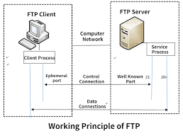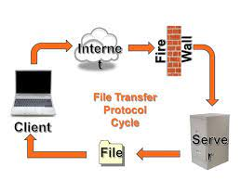

Key features and characteristics of FTP include:

1. **Client-Server Architecture:** FTP follows a client-server model. The client is a software application running on the user's computer, while the server is a computer system hosting the FTP service and the files available for transfer.
2. **Port Numbers:** FTP uses two separate ports for communication. Port 21 is used for the control channel, where commands and responses are exchanged between the client and server. Port 20 (or a dynamically assigned port) is used for the data channel, where the actual file data is transferred.
3. **Commands and Responses**: FTP operates through a set of commands and responses. The client sends commands to the server, instructing it to perform various operations, such as listing directories, uploading files, or downloading files. The server responds to these commands with status codes and messages.
4. **Modes of Operation**: FTP supports two modes of operation for data transfer: active mode and passive mode. In active mode, the client opens a random port for data transfer, and the server connects to that port. In passive mode, the server opens a random port for data transfer, and the client connects to that port. Passive mode is often used in situations where the client is behind a firewall or NAT.
5. **Authentication:** FTP typically requires users to authenticate themselves with a username and password to access the files on the server. However, FTP by itself does not provide strong security, and credentials are transmitted in clear text, making it vulnerable to eavesdropping. For secure file transfers, protocols like FTPS (FTP Secure) or SFTP (SSH File Transfer Protocol) are used.
6. **Anonymous FTP**: Some FTP servers allow anonymous access, where users can log in as "anonymous" without a password. This is often used for public file repositories, allowing users to download files without the need for individual user accounts.
7. **File Operations**: FTP supports various file operations, such as uploading (putting) files from the client to the server, downloading (getting) files from the server to the client, renaming files, deleting files, and listing the contents of directories on the server.s